
UK PROJECT
BRINSWORTH TO CHESTERFIELD
Document Reference EDEU-WSP-ENVS-ZZZZZZ-RPT-EV-000001
Equality Impact Assessment
14 July 2026
P01
Document Reference: EDEU-WSP-ENVS-ZZZZZZ-RPT-EV-000001 PA-Publicaly Available
EXPORT CONTROLLED: Y i

UK PROJECT | 

DOCUMENT DETAILS
Table 1: Document Details
Project Ref.
Document Ref No. EDEU-WSP-ENVS-ZZZZZZ-RPT-EV-000001
Document Title Equality Impact Assessment

Rev No. | P01 |  | Status Code | S3

Scheme No.
XX
NG Document No. -
Discipline
Environment
Investment No.
-
Document Owner | WSP

APPROVAL SIGN OFF
Table 2: Approval Sign-off

 | Prepared By | Checked By | Approved By
Name | Angharad Hill, WSP | Lucy Ives, WSP | Sheri Shai, WSP
Title | Graduate Consultant | Senior Consultant | Associate Consultant
Signature | AH | LI | SS
Date | 07/08/2026 | 07/08/2026 | 07/08/2026

EDEU-WSP-ENVS-ZZZZZZ-RPT-EV-000001 PA-Publicaly Available
EXPORT CONTROLLED: Y 2

UK PROJECT

CONTRACT REVISION HISTORY
Table 3: Contract Revision History
Rev Status Amendment Prepared By Date

P01 | S3 | Shared for review and comment | Angharad Hill, WSP 07/08/2026
EDEU-WSP-ENVS-ZZZZZZ-RPT-EV-000001 PA-Publicaly Available
EXPORT CONTROLLED: Y 3

UK PROJECT

CONTENTS
DOCUMENT DETAILS 2
APPROVAL SIGN OFF 2
CONTRACT REVISION HISTORY 3
- INTRODUCTION 6
1.1 Project Background 6
1.2 Purpose of the Equality Impact Assessment 6
- Scheme Description 8
2.1 The Project: Brinsworth to Chesterfield 8
2.2 Compulsory Purchase 8
2.3 Further Guidance 9
2.4 Structure of Equality Impact Assessment 9
- Approach to Equality Impact Assessment 11
3.1 Assessment Methodology 11
Approach to Screening 11
Approach to Equality Impact Assessment 11
3.2 Study Area 12
- Consultation 14
4.1 Stakeholder Engagement 14
4.2 Landowner Engagement 14
- Social Baseline 16
5.2 Protected Characteristics Profile 16
Race 16
Religion or Belief 19
Age 21
Sex 24
Disability 26
Marriage and Civil Partnership 29
Sexual Orientation 32
Gender Identity and Reassignment 32
EDEU-WSP-ENVS-ZZZZZZ-RPT-EV-000001 PA-Publicaly Available
EXPORT CONTROLLED: Y 4

UK PROJECT

Pregnancy and Maternity 33
Deprivation 35
5.3 Communities in Proximity to the Project 35
5.4 Public Transport, Pedestrian and Cycling Facilities 35
Public Transport 36
Walkers, Cyclists and Horse-riders 36
5.5 Equality Receptors 36
Residential Receptors 37
Educational Facilities 37
Community Assets and Other Facilities 37
6. | Equality Impact Screening | 38
6.2 | Race | 39
6.3 | Religion or Belief | 39
6.4 | Age | 39
6.5 | Sex (Including Pregnancy and Maternity) | 39
6.6 | Disability | 40
6.7 | Marriage and Civil Partnership | 40
6.8 | Sexual Orientation | 40
6.9 | Gender Identity / Reassignment | 40
6.10 | Deprivation | 41
6.11 | Summary | 41
7. | Equality Impact Assessment | 42
8. | Conclusions | 46

EDEU-WSP-ENVS-ZZZZZZ-RPT-EV-000001 PA-Publicaly Available
EXPORT CONTROLLED: Y 5

UK PROJECT

1. INTRODUCTION
1.1 Project Background
1.1.1 National Grid Electricity Transmission plc (National Grid) is preparing to make a compulsory purchase order (CPO) under Section 10 of the Electricity Act 1989 to support the acquisition of land and rights over land to enable them to deliver the EDEU Project (‘the Project’).
1.1.2 The Project comprises the uprating of the transmission network between Brinsworth and High Marnham, including new substations at Long Lane, Chesterfield and High Marnham. The Project works are supported by three Town and Country Planning Act 1990 (TCPA) applications and two applications for consent under section 37 of The Electricity Act 1989.
1.1.3 WSP has been commissioned by National Grid to prepare two Equality Impact Assessments (EqIA) to accompany proposals for the Compulsory Purchase Order (CPO) of land and rights along the route of the Project. This EqIA will consider effects on the Brinsworth to Chesterfield CPO. This document presents an assessment of the potential equality effects, including a description of the relevant baseline characteristics of the surrounding area, identification of direct effects arising from the CPO and an assessment of wider effects which may arise from the Project.
1.1.4 Additional mitigation measures have been identified where appropriate to avoid, reduce or offset any adverse effects identified and/or enhance likely beneficial effects.
1.2 Purpose of the Equality Impact Assessment
1.2.1 The Equality Act 2010 provides people with legal protection from discrimination. It sets out different ways in which it is unlawful for someone to be treated. The Public Sector Equality Duty (the PSED) was created under the Equality Act 2010 and requires public authorities to have due regard to:
- Eliminate discrimination, removing or minimising disadvantages suffered by people due to their protected characteristics;
- Advance equality, taking steps to meet the needs of people from protected groups where these are different from the needs of other people; and
- Foster good relations, encouraging people from protected groups to participate in public life or in other activities where their participation is disproportionately low.
1.2.2 The purpose of this EqIA is to identify and address potential equality impacts that may arise as a result of the CPO process. This relates to impacts of the CPO on people with relevant protected characteristics under the Equality Act 2010 who live or work in areas affected by the Project. Protected characteristics (defined in section 149 of the Equality Act 2010) are:
- Race;
EDEU-WSP-ENVS-ZZZZZZ-RPT-EV-000001 PA-Publicaly Available
EXPORT CONTROLLED: Y 6

UK PROJECT

- Religion or Belief;
- Age;
- Sex;
- Disability;
- Mariage and Civil Partnership;
- Sexual Orientation;
- Gender Identity and Ressignment; and
- Pregnancy and maternity.
1.2.3 Although deprivation is not a protected characteristic under the Equality Act 2010, the
EqIA has included this vulnerable group to consider people at risk of socio-economic disadvantage. Additionally National Grid is not subject to the PSED, however considering equality effects demonstrates National Grid’s ambition to contribute to a more equitable society. This document will be used to assist the Secretary of State when making their decision to grant the CPO. National Grid’s commitment to equality is outlined through the organisation’s values and Diversity, Equality and Inclusion (DEI) Strategy¹ as well as the National Grid Code of Ethics² which has clear objectives and greater accountability around the organisation with regard to Diversity, Equality and Inclusion.
1.2.4 This document will remain live until the commencement of the CPO process. It will be
updated at appropriate points to incorporate the latest findings from engagement with landowners and tenants.
1 National Grid (2026) Inclusion and Diversity. Available at: https://www.nationalgrid.com/careers/inclusion-and-diversity (Accessed July 2026).
2 National Grid (2026) Our Code of Ethics. Available at: https://www.nationalgrid.com/document/149001/download (Accessed July 2026).
EDEU-WSP-ENVS-ZZZZZZ-RPT-EV-000001 PA-Publicaly Available
EXPORT CONTROLLED: Y 7

UK PROJECT

2. Scheme Description
2.1 The Project: Brinsworth to Chesterfield
2.1.1 The Brinsworth to Chesterfield part of the Project involves the construction of one new substation, at Long Lane, east of Brinsworth, (the “Long Lane Substation”). Additionally, the existing overhead line (OHL) will be uprated from 275kV to 400kV. The existing line exits the existing Brinsworth Substation, before travelling in a southerly direction passing through Swallownest, and east of Sothall. It continues south, passing east of Staveley before reaching the existing substation at Calow Lane, Chesterfield. The route is shown in Figure 1.
2.2 Compulsory Purchase
2.2.1 Compulsory purchase powers enable bodies to acquire land and rights over land compulsorily. CPO powers are used as a means of assembling land to help deliver infrastructure and ensure it can be maintained. Compulsory purchase is intended as a last resort and should only take place where there is a compelling case in the public interest. National Grid may make a CPO for the purposes of its activities authorised under the Electricity Act 1989.
2.2.2 As part of the CPO process, the Public Sector Equality Duty should be considered by public sector acquiring authorities. This is set out in guidance on the Compulsory Purchase Process³. The document identifies that throughout the compulsory purchase process acquiring authorities must have due regard to the need to:
- “(a) eliminate unlawful discrimination, harassment, victimisation;
- “(b) advance equality of opportunity between persons who share a relevant protected characteristic and persons who do not share it; and
- “(c) foster good relations between persons who share a relevant protected characteristic and persons who do not share it.”
2.2.3 The document also sets out the process for a CPO including engaging with those affected, making an order, notification, matters considered and process when the Secretary of State decides whether to confirm a CPO, implementation and compensation.
2.2.4 For this Project, CPO powers are being sought for a number of land parcels. While National Grid aims to acquire these rights through voluntary agreements, the CPO powers enable National Grid to proceed with compulsory acquisition if voluntary negotiations with landowners are unsuccessful. Landowners have the right to object to a CPO and there may be a public inquiry if this is the case.
3 Ministry of Housing, Communities and Local Government (2026) Guidance on the Compulsory Purchase Process. Available at: https://assets.publishing.service.gov.uk/media/6a327dabc6e94f095f3ef949/CPO_Guidance_Update_2026.pdf (Accessed July 2026).
EDEU-WSP-ENVS-ZZZZZZ-RPT-EV-000001 PA-Publicaly Available
EXPORT CONTROLLED: Y 8

UK PROJECT

2.2.5 If National Grid is unable to acquire the necessary land rights voluntarily and compulsory powers are used, the entitlement to compensation for affected parties, and the process for determining the appropriate amount, is governed by a combination of legislation, case law, and established practices.
2.3 Further Guidance
2.3.1 Aside from the Equality Act 2010 and the CPO legislation and guidance referred to above, the following policy and guidance has been considered when producing the EqIA.
- Chesterfield Borough Council Equality and Diversity Strategy⁴
- Derbyshire County Council – Public Duty to Promote Equality⁵
- Rotherham Metropolitan Borough Council – Inclusion Strategy⁶
- Sheffield City Council Equality Objectives 2024 - 2028⁷
- North East Derbyshire District Council Equality Duty and Plan Review⁸
- Highways England (now National Highways) Equality Impact Assessment Guidance⁹; and
- Design Manual for Roads and Bridges (DMRB) LA 112: Population and Human Health¹⁰.
2.4 Structure of Equality Impact Assessment
2.4.1 The structure of the document will be as follows:
- Section 3: Details the approach to the EqIA, including the justification of the Study Area and data sources used.
- Section 4: Presents an overview of consultation undertaken to date.
4 Chesterfield Borough Council (2026) Equality and Diversity. Available at: https://www.chesterfield.gov.uk/living-here/people-and-families/equality-and-diversity/ (Accessed July 2026).
⁵ Derbyshire County Council (2026). Public Duty to Promote Equality. Available at: https://www.derbyshire.gov.uk/council/equalities/public-duty-to-promote-equality/public-duty-to-promote-equality.aspx (Accessed July 2026).
⁶ Rotherham Metropolitan Borough Council. (2026) Inclusion. Available at: https://www.rotherham.gov.uk/council/equality-diversity-inclusion (Accessed July 2026).
⁷ Sheffield City Council (2026) Equality Objectives 2024 – 2028. Available at:
https://www.sheffield.gov.uk/campaigns/equality-objectives (Accessed July 2026).
8 North East Derbyshire District Council (2025). The Equality Duty and Plan Review. Available at: https://www.ne-derbyshire.gov.uk/news-and-media/latest-news/the-equality-duty-and-plan-review (Accessed July 2026).
9 Highways England (now National Highways) (2016). The Little Guide to a Big Issue
10 Design Manual for Roads and Bridges (2020) LA 112 Population and Human Health. Available at: https://www.standardsforhighways.co.uk/tses/attachments/1e13d6ac-755e-4d60-9735-f976bf64580a?inline=true . (Accessed August 2026).
EDEU-WSP-ENVS-ZZZZZZ-RPT-EV-000001 PA-Publicaly Available
EXPORT CONTROLLED: Y 9

UK PROJECT

- Section 5: Presents an overview of key demographic data and equality receptors in relation to protected characteristics within the Study Area.
- Sections 6 and 7: Provides an assessment of potential equality impacts, including mitigation measures.
- Section 8: Summarises the findings and includes information on the next steps.
EDEU-WSP-ENVS-ZZZZZZ-RPT-EV-000001 PA-Publicaly Available
EXPORT CONTROLLED: Y 10

UK PROJECT

3. Approach to Equality Impact
Assessment
3.1 Assessment Methodology
3.1.1 National Highways has developed guidance¹¹ to inform the EqIA process for highways schemes. This guidance has been used as industry practice for the highways sector and it has informed the EqIA approach set out here. The approach has also considered the Design Manual for Roads and Bridges (DMRB) LA 112 and the guidance referenced in Section 2.3. A two-step approach has been considered for the assessment, with a screening stage used to determine whether an EqIA is required, and if so, for which protected characteristic groups.
Approach to Screening
3.1.2 The screening exercise undertaken as part of this EqIA has considered:
- Whether there is evidence to suggest that any of the ‘protected characteristic groups’ have particular sensitivities or needs in relation to the Project;
- Whether there are existing inequalities or access barriers to services or developments which need to be considered; and
- Whether there are particular community groups or stakeholders representing ‘protected characteristics’ who have expressed interest or concerns about the Project.
3.1.3 In order to complete the screening exercise, an initial desk-top review of existing baseline information to gather data and understand the communities which may be affected by the Project has been undertaken. This included a review of previously published, publicly available documents, as well as the compilation of a baseline using Census 2021 and NOMIS data and information held by the local authorities. Additionally, the ‘protected characteristic’ groups and equality receptors within the Study Area (set out in Section 3.2)were identified where there was the potential for them to experience disproportionate impacts as a result of the CPO. ‘Protected characteristic’ groups may be more likely to be affected, or use particular assets and services such as schools or healthcare facilities, therefore these assets are included as equality receptors.
Approach to Equality Impact Assessment
3.1.4 Equality receptors were identified as part of the baseline (section 5), and help to inform the assessment as they can be used to identify services and assets that people belonging to protected characteristic groups may use. Where the Project affects these
11 Highways England (now National Highways) (2016). The Little Guide to a Big Issue.
EDEU-WSP-ENVS-ZZZZZZ-RPT-EV-000001 PA-Publicaly Available
EXPORT CONTROLLED: Y 11

UK PROJECT

assets, people from protected characteristic groups may be disproportionately affected.
3.1.5 Following the Screening exercise (section 6), the EqIA assesses the impacts of the
CPO on protected characteristic groups and those who may experience deprivation identified as likely to experience a disproportionate impact as a result of the Project. The Screening exercise considered which of the protected characteristic groups have the potential to experience disproportionate impacts (in comparison to those not falling under the protected characteristic group), as a result of the CPO.
3.1.6 Table 1 outlines the basis of the assessment criteria which have been used for the
purposes of this EqIA (derived from and informed by the guidance documents outlined in paragraph 2.3.1), determining whether a high, medium or low, negative or positive impact for each of the protected characteristic groups is assigned. These criteria are based on professional judgement in the absence of industry guidance criteria. These criteria are guidelines only, and should not be treated as definitive and universal standards for all EqIA assessment.
Table 1: Equality Impact Assessment Criteria
3.2 Study Area

High negative / positive Medium negative / Low negative / positive
impact positive impact impact
Extent: Likely to affect the well-being of most or all people from the specified equality group.
Duration: Long term.
Reversibility: Not likely to be.
Extent: Likely to affect the well-being of many people from the specified equality group.
Duration: Medium term.
Reversibility: Likely to be to some extent
Extent: Likely to affect a small number of people from one or more equality groups.
Duration: Short-medium term.
Reversibility: Likely to be.
3.2.1 The EqIA has been based on the following geographical areas. These areas have been identified based on the location of the Project and professional judgement.
- Protected Characteristic Profile – census data and other publicly available information has been gathered for the below lower-layer super output areas (LSOA) , the districts of Rotherham, Sheffield, Chesterfield and North East Derbyshire and wider Yorkshire and Humber / Derbyshire area to provide a baseline of the demographic of the area for the protected characteristics. LSOAs are a standard statistical geography designed to be of a similar population size, with an average of approximately 1,500 residents or 650 households.;
- Rotherham 027E
- Rotherham 034G
EDEU-WSP-ENVS-ZZZZZZ-RPT-EV-000001 PA-Publicaly Available
EXPORT CONTROLLED: Y 12

UK PROJECT

- Rotherham 027D
- Rotherham 027C
- Rotherham 026A
- Rotherham 031A
- Rotherham 027H
- Sheffield 056A
- Sheffield 063A
- Sheffield 063B
- Sheffield 063D
- Sheffield 065A
- North East Derbyshire 001E
- North East Derbyshire 001F
- North East Derbyshire 014C
- North East Derbyshire 007C
- North East Derbyshire 007B
- Chesterfield 002A
- Chesterfield 002B
- Chesterfield 002C
- Chesterfield 002D
- Chesterfield 006A
- Chesterfield 006C
- Equality Receptors – in order to capture those equality receptors that may be
affected by the CPO, receptors within the CPO Boundary or immediately
adjacent to it have been considered. Receptors include:
- Nearby residential and commercial properties;
- Schools;
- Care homes;
- Hospitals;
- Places of worship;
- Community facilities;
- Food banks; and
- Public transport.
EDEU-WSP-ENVS-ZZZZZZ-RPT-EV-000001 PA-Publicaly Available
EXPORT CONTROLLED: Y 13

UK PROJECT

4. Consultation
4.1 Stakeholder Engagement
4.1.1 To date, there have been no consultations specific to the EqIA, however consultation events have been held prior to submission of the TCPA application at Brinsworth. The National Grid project team hosted a webinar on Tuesday 9 July 2024 and two public consultation events took place Wednesday 10 and Thursday 11 July 2024. The event on Wednesday 10 July 2024 took place at Whiston Village Hall and the event on Thursday 11 July 2024 took place in the Centre, Brinsworth. These sessions provided an opportunity for the team to share details regarding the proposals with residents, invite the public to meet the team and respond to questions. These events were supported by a consultation website which could be viewed at any time online. The website was made publicly available from 20 May 2024 and feedback was accepted until 11:59pm on 22 July 2024. During this process 49 individuals attended and eight registered to attend the webinar. Feedback received included using the Community Benefit Fund to support open spaces for community use.
4.1.2 As the CPO process develops, any further consultation will be recorded here.
4.2 Landowner Engagement
4.2.1 It should be noted that the following process will be followed for those landowners that are affected by the CPO. During negotiations with Persons with an Interest in Land (PiLs) and their agents, several measures will be taken to ensure that all PiLs, whether they have protected characteristics or not, are able to fully participate with the negotiations for voluntary agreements and with the Compulsory Purchase Order (CPO) process.
4.2.2 Every landowner and occupier is encouraged to appoint a professional representative, normally an RICS qualified land agent, to advise them during the CPO process and in negotiations of the voluntary agreements. National Grid meets the reasonable costs of this professional representation in line with the Compensation Code.
4.2.3 Correspondence takes place through the preferred communication method, including where some landowners have asked for communications to take place through their agents only.
4.2.4 Private meetings take place in the landowner’s preferred location, be it their homes or their places of work, or their agent’s offices. Where appropriate, videocalls are also utilised. Meeting summaries and minutes are issued as a follow-up to ensure all actions are logged and that the affected parties have a summary of the conversation and understand the next steps in relation to their negotiations.
4.2.5 Continual engagement with affected parties is taking place. National Grid will consider
required or requested allowances and have communicated and treated those landowners in line with their requirements and requests.
EDEU-WSP-ENVS-ZZZZZZ-RPT-EV-000001 PA-Publicaly Available
EXPORT CONTROLLED: Y 14

UK PROJECT

4.2.6 National Grid employs Surveyors and will employ Agricultural Liaison Officers through
their Land Agents and Contractor. The Surveyors are currently responsible for the day-to-day PiL relationships outside of the Voluntary Agreement negotiations. The ALOs once employed will allow the PiLs and their agents to have a dedicated site based point of contact to discuss practical matters and concerns as well as survey and access interactions with the Project.
EDEU-WSP-ENVS-ZZZZZZ-RPT-EV-000001 PA-Publicaly Available
EXPORT CONTROLLED: Y 15

UK PROJECT

5. Social Baseline
5.1.1 The social profile for the Project has been compiled from publicly available data to provide context for and to inform the assessment. This comprises information on the following:
- Protected characteristic groups;
- Local communities; and
- Local community facilities and public transport.
5.2 Protected Characteristics Profile
5.2.1 Data from the Office of National Statistics (ONS) has been gathered on the following protected characteristics from Section 4 of the Act:
- Race including colour, nationality ethnic or national origin;
- Religion or belief;
- Age;
- Sex;
- Disability;
- Marital and civil partnership;
- Sexual Orientation; and
- Gender Identity and Reassignment.
- Pregnancy and maternity
5.2.2 Although not required under the Act, the social profile does also include deprivation as it provides a measure of a combination of social-economic matrices.
Race
5.2.3 The proportion of the population belonging to each ethnic group, as measured by the ONS is presented in Table 2. It shows that across each of the LSOAs within the Study Area, the proportion of population classified as White is somewhat higher than the England average. LSOA Rotherham 034G has the lowest proportion of White residents (90.7%); compared with 98.9% in Chesterfield 006C. Sheffield generally is more ethnically diverse compared to the other districts. Across LSOA Sheffield 056A, Sheffield 063A, Sheffield 063B, Sheffield 063D and Sheffield 065A, the proportion of the population recorded as Mixed/Multiple Ethnic Groups, Asian/Asian British/Asian Welsh, Black/ Black British/ Black Welsh/ Caribbean or African and Other ethnic group is lower than the Sheffield averages, suggesting a lower concentration of people belonging to these ethnicities in this area which interacts with the Project.
EDEU-WSP-ENVS-ZZZZZZ-RPT-EV-000001 PA-Publicaly Available
EXPORT CONTROLLED: Y 16

UK PROJECT

Table 2: Percentage ethnicity breakdown of the Project (2021)¹²
Ethnic Group
LSOA
 | White | Mixed/Multiple Ethnic  Groups: | Asian/Asian British/Asian Welsh: | Black/ Black British/ Black Welsh/ Caribbean or African | Other ethnic group
Rotherham 027E | 92.8% | 1.0% | 3.8% | 1.6% | 0.9%
Rotherham 034G | 90.7% | 1.9% | 6.1% | 0.7% | 0.6%
Rotherham 027D | 95.8% | 0.9% | 2.0% | 1.1% | 0.3%
Rotherham 027C | 93.9% | 2.2% | 2.5% | 0.9% | 0.5%
Rotherham 026A | 98.2% | 0.5% | 0.9% | 0.1% | 0.4%
Rotherham 031A | 93.5% | 2.0% | 2.7% | 0.8% | 0.9%
Rotherham 027H | 94.1% | 2.3% | 2.4% | 1.1% | 0.1%
Sheffield 056A | 94.1% | 3.5% | 1.4% | 0.9% | 0.2%
Sheffield  063A | 96.5% | 2.0% | 0.8% | 0.6% | 0.1%
Sheffield  063B | 98.4% | 0.6% | 0.9% | 0.0% | 0.2%
Sheffield 063D | 95.2% | 1.0% | 2.1% | 1.5% | 0.2%
Sheffield 065A | 92.6% | 3.3% | 2.5% | 1.3% | 0.2%
North East Derbyshire | 98.1% | 1.6% | 0.2% | 0.1% | 0.0%
001E
12 Nomis (2021) Local Area Profiles. Available at:
https://www.nomisweb.co.uk/reports/localarea?compare=E07000146#section_4. (Accessed July 2026).
EDEU-WSP-ENVS-ZZZZZZ-RPT-EV-000001 PA-Publicaly Available
EXPORT CONTROLLED: Y 17

UK PROJECT

Ethnic Group

Country

District

White | Mixed/Multiple Ethnic  Groups: | Asian/Asian British/Asian Welsh: | Black/ Black British/ Black Welsh/ Caribbean or African | Other ethnic group
North East 97.8%  Derbyshire  001F | 0.8% | 0.8% | 0.3% | 0.3%
North East 96.3%  Derbyshire  014C | 1.6% | 0.9% | 0.8% | 0.3%
North East 96.2%  Derbyshire  007C | 2.0% | 0.7% | 0.8% | 0.3%
North East 97.6%  Derbyshire  007B | 0.6% | 1.4% | 0.3% | 0.1%
Chesterfield 94.2%  002A | 1.7% | 1.0% | 2.1% | 1.1%
Chesterfield 97.1%  002B | 1.6% | 0.5% | 0.5% | 0.4%
Chesterfield 96.0%  002C | 1.2% | 1.5% | 1.3% | 0.0%
Chesterfield 96.4%  002D | 2.4% | 0.3% | 0.4% | 0.3%
Chesterfield 96.4% 006A | 2.1% | 1.1% | 0.3% | 0.2%
Chesterfield 98.9% 006C | 0.3% | 0.8% | 0.0% | 0.1%
Rotherham 91.0% | 1.4% | 5.3% | 1.1% | 1.1%
Chesterfield 95.5% | 1.4% | 1.9% | 0.8% | 0.4%
North East 97.4%  Derbyshire | 1.1% | 0.9% | 0.3% | 0.2%
Sheffield 79.1% | 3.5% | 9.6% | 4.6% | 3.2%
England 81.0% | 3.0% | 9.6% | 4.2% | 3.0%

*Note: Percentages may not sum exactly due to rounding.
EDEU-WSP-ENVS-ZZZZZZ-RPT-EV-000001 PA-Publicaly Available
EXPORT CONTROLLED: Y 18

UK PROJECT

Religion or Belief
5.2.4 The proportion of different religions or beliefs held by the population in the LSOAs within the CPO Boundary, in Rotherham, Sheffield, North east Derbyshire, Chesterfield, and England are provided in Table 3. The table shows that the majority of the population in Rotherham, North East Derbyshire and Chesterfield identify as Christian, followed by those with no religion. In contrast, the majority of the population have no religion (43.4%) in Sheffield. The Census 2021 data also indicate that the proportion of residents reporting no religion is slightly higher in all districts than the England average (36.7%).
5.2.5 At LSOA level, there is a higher proportion of the population who identify as Christian or having no religion across the majority of LSOA areas when compared to the England average. Within both LSOA Rotherham 026A and Chesterfield 006C, residents identifying as Christian represents the largest religious group (60.4% and 60.1%), somewhat higher than all the other LSOAs, the Rotherham district (49.0%) and England average (46.3%) levels.
EDEU-WSP-ENVS-ZZZZZZ-RPT-EV-000001 PA-Publicaly Available
EXPORT CONTROLLED: Y 19

UK PROJECT

Table 3: Percentage religion breakdown of the Project (2021)¹³

Religion
Hindu
No
religion
Buddhist
Muslim
Jewish
Christian
Sikh
Other
Religion
Not
Answered
LSOA
Rotherham 027E | 44.8% | 46.4% | 0.0% | 0.0% | 0.0% | 4.6% | 0.0% | 0.3% | 3.9%
Rotherham 034G | 32.9% | 54.7% | 0.1% | 0.8% | 0.0% | 5.6% | 0.3% | 0.3% | 5.2%
Rotherham 027D | 45.1% | 48.0% | 0.2% | 0.4% | 0.0% | 0.6% | 0.1% | 0.1% | 5.5%
Rotherham 027C | 41.7% | 50.1% | 0.0% | 1.2% | 0.0% | 0.8% | 0.0% | 0.5% | 5.7%
Rotherham 026A | 34.0% | 60.4% | 0.1% | 0.1% | 0.0% | 0.6% | 0.0% | 0.2% | 4.5%
Rotherham 031A | 42.9% | 49.7% | 0.6% | 0.0% | 0.0% | 1.3% | 0.3% | 0.4% | 4.6%
Rotherham 027H | 46.4% | 43.5% | 0.0% | 0.7% | 0.1% | 0.5% | 0.5% | 0.1% | 8.2%
Sheffield 056A | 47.7% | 43.1% | 0.2% | 0.3% | 0.1% | 0.6% | 0.1% | 0.1% | 7.8%
Sheffield 063A | 50.2% | 43.8% | 0.2% | 0.3% | 0.1% | 0.1% | 0.0% | 0.3% | 5.0%
Sheffield 063B | 43.8% | 49.7% | 0.1% | 0.3% | 0.1% | 0.4% | 0.0% | 0.1% | 5.5%
Sheffield 063D | 47.5% | 47.2% | 0.2% | 0.2% | 0.0% | 1.2% | 0.0% | 0.2% | 3.6%
Sheffield 065A | 49.0% | 42.9% | 0.2% | 0.2% | 0.0% | 0.7% | 0.1% | 0.6% | 6.4%
North East Derbyshire 001E | 43.4% | 50.3% | 0.6% | 0.1% | 0.0% | 0.0% | 0.0% | 0.2% | 5.4%
North East Derbyshire 001F | 40.4% | 54.8% | 0.1% | 0.1% | 0.0% | 0.1% | 0.3% | 0.3% | 3.7%
North East Derbyshire 014C | 43.7% | 50.1% | 0.0% | 0.0% | 0.0% | 0.1% | 0.2% | 0.1% | 5.7%
North East Derbyshire 007C | 42.9% | 50.7% | 0.1% | 0.0% | 0.0% | 0.5% | 0.0% | 0.1% | 5.7%

13 Nomis (2021) Local Area Profiles. Available at:
https://www.nomisweb.co.uk/reports/localarea?compare=E07000146#section_4. (Accessed July 2026).
EDEU-WSP-ENVS-ZZZZZZ-RPT-EV-000001 PA-Publicaly Available
EXPORT CONTROLLED: Y 20

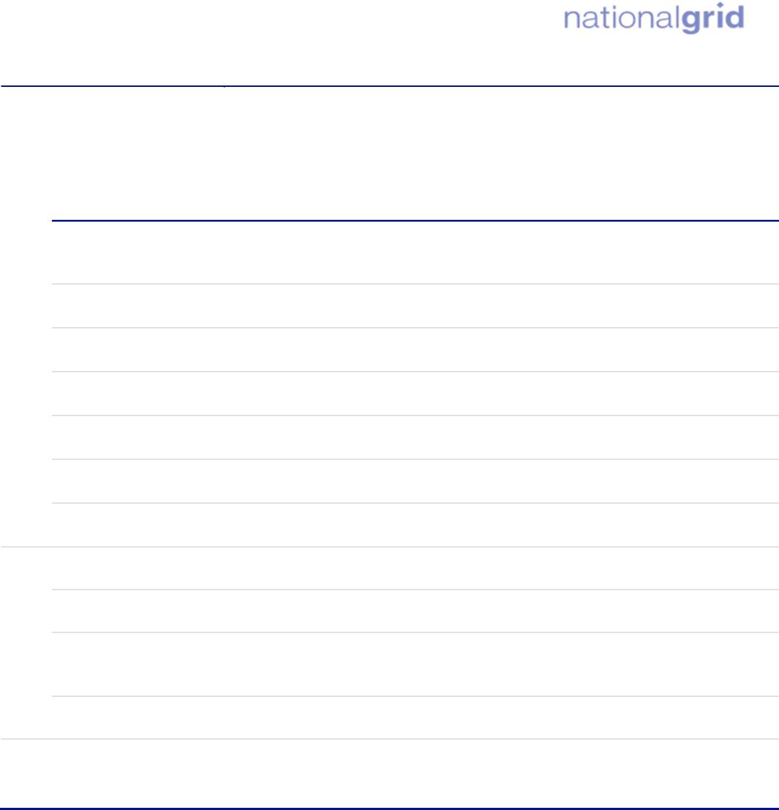
UK PROJECT
Hindu
Jewish
Muslim
Buddhist
Sikh
Christian
No
religion
Other
Religion
Not
Answered
Religion
North East Derbyshire 007B | 37.5% | 56.1% | 0.3% | 0.0% | 0.0% | 0.2% | 0.0% | 0.2% | 5.8%
Chesterfield 002A | 52.8% | 37.3% | 0.1% | 0.5% | 0.0% | 2.3% | 0.3% | 0.3% | 6.6%
Chesterfield 002B | 41.3% | 53.4% | 0.1% | 0.4% | 0.0% | 0.3% | 0.1% | 0.3% | 4.1%
Chesterfield 002C | 45.9% | 47.8% | 0.4% | 0.2% | 0.1% | 0.7% | 0.0% | 0.2% | 4.7%
Chesterfield 002D | 54.3% | 39.5% | 0.0% | 0.0% | 0.0% | 1.0% | 0.0% | 0.8% | 4.3%
Chesterfield 006A | 46.8% | 45.4% | 0.1% | 0.0% | 0.0% | 1.0% | 0.2% | 0.4% | 6.1%
Chesterfield 006C | 35.0% | 60.1% | 0.2% | 0.1% | 0.0% | 0.2% | 0.0% | 0.1% | 4.4%
Rotherham | 39.8% | 49.0% | 0.2% | 0.3% | 0.0% | 5.1% | 0.2% | 0.4% | 5.2%
Chesterfield | 44.5% | 47.7% | 0.3% | 0.3% | 0.0% | 0.9% | 0.2% | 0.5% | 5.6%
North East Derbyshire | 42.3% | 50.9% | 0.2% | 0.1% | 0.1% | 0.3% | 0.1% | 0.4% | 5.5%
Sheffield | 43.4% | 38.5% | 0.4% | 0.7% | 0.1% | 10.3% | 0.2% | 0.5% | 6.0%
England | 36.7% | 46.3% | 0.5% | 1.8% | 0.5% | 6.7% | 0.9% | 0.6% | 6.0%

Country
District
*Note: Percentages may not sum exactly due to rounding.
Age
The age profile in the LSOAs within which the Project is located, compared to the Districts and England averages is provided in Table 4 below. When compared with England as a whole, the three districts of Rotherham, Chesterfield and North East Derbyshire have a slightly higher proportion of people aged 65 and over. Chesterfield and North East Derbyshire also have a lower proportion of the population aged under 15 years old, suggesting an ageing population. LSOA Chesterfield 006C also reflects this, with the highest proportion of the population aged 65 and over (39.6%) when compared to all other LSOAs and district averages and the England average, suggesting a high concentration of those aged 65 and over in this area. Conversely, LSOA Chesterfield 002A has a much higher proportion of under 16 years old (25.7%) when compared with the districts and England (18.5%) averages.
Sheffield 063A
6.3%
5.0%
7.8%
3.3%
4.9%
14.6%
16.4%
21.9%
9.7%
5.6%
4.6%
EDEU-WSP-ENVS-ZZZZZZ-RPT-EV-000001 PA-Publicaly Available
EXPORT CONTROLLED: Y 21

UK PROJECT

Table 4: Percentage age breakdown of the Project (2021)¹⁴
Age

10-15 years
16-19 years
75-84 years
5-9 years
0-4 years
85+ years
35-49 years
50-64 years
25-34 years
65-74 years
20-24 years
LSOA
Rotherham 027E | 4.9% | 5.5% | 5.9% | 3.9% | 5.5% | 13.7% | 18.6% | 23.8% | 12.0% | 5.4% | 0.9%
Rotherham 034G | 3.7% | 4.4% | 6.7% | 4.0% | 4.4% | 10.2% | 18.0% | 23.5% | 12.8% | 9.3% | 3.0%
Rotherham 027D | 5.7% | 5.6% | 7.8% | 3.9% | 6.7% | 14.5% | 19.5% | 18.5% | 9.9% | 6.0% | 2.0%
Rotherham 027C | 4.9% | 6.6% | 8.3% | 5.0% | 5.5% | 13.0% | 21.5% | 21.3% | 7.1% | 4.9% | 1.9%
Rotherham 026A | 3.6% | 4.6% | 4.1% | 2.5% | 4.4% | 8.3% | 13.2% | 28.0% | 19.6% | 8.7% | 2.9%
Rotherham 031A | 5.8% | 6.1% | 8.5% | 4.7% | 4.8% | 11.6% | 21.3% | 20.3% | 10.0% | 6.0% | 0.9%
Rotherham 027H | 5.9% | 5.7% | 8.2% | 5.4% | 5.3% | 11.8% | 19.3% | 22.1% | 7.5% | 4.8% | 3.9%
Sheffield 056A | 5.3% | 6.7% | 7.3% | 4.9% | 5.1% | 13.6% | 18.3% | 22.9% | 8.5% | 5.8% | 1.6%
Sheffield  063A | 6.3% | 5.0% | 7.8% | 3.3% | 4.9% | 14.6% | 16.4% | 21.9% | 9.7% | 5.6% | 4.6%
Sheffield  063B | 3.9% | 5.0% | 7.2% | 3.7% | 3.9% | 10.0% | 16.2% | 27.2% | 12.3% | 8.5% | 2.1%
Sheffield 063D | 4.9% | 4.5% | 6.4% | 4.0% | 5.6% | 11.5% | 18.5% | 28.5% | 11.6% | 3.4% | 1.0%
Sheffield | 6.1% | 6.5% | 7.2% | 4.3% | 5.4% | 12.4% | 19.8% | 20.3% | 10.2% | 6.6% | 1.5%
065A
14 Nomis (2021) Local Area Profiles. Available at:
https://www.nomisweb.co.uk/reports/localarea?compare=E07000146#section_4. (Accessed July 2026).
EDEU-WSP-ENVS-ZZZZZZ-RPT-EV-000001 PA-Publicaly Available
EXPORT CONTROLLED: Y 22

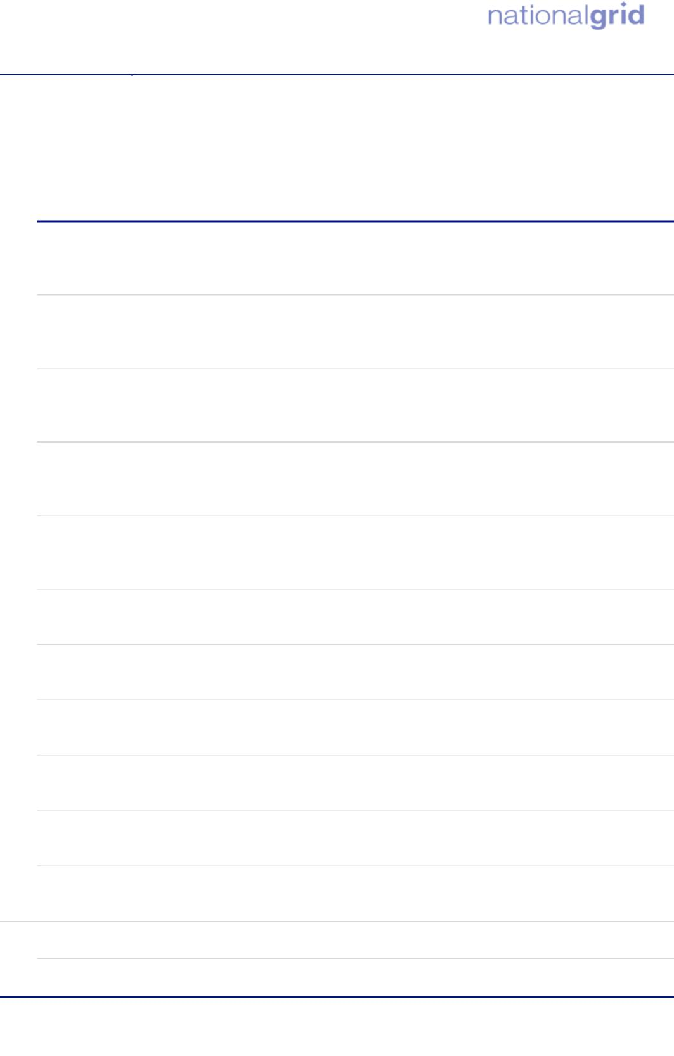
UK PROJECT
10-15 years
25-34 years
50-64 years
75-84 years
0-4 years
5-9 years
16-19 years
20-24 years
35-49 years
65-74 years
85+ years
Age
North East 5.7%  Derbyshire  001E | 4.9% | 6.2% | 4.6% | 5.2% | 11.3% | 16.5% | 23.3% | 13.0% | 8.3% | 1.1%
North East 4.3%  Derbyshire  001F | 5.0% | 4.5% | 2.2% | 4.7% | 11.3% | 17.7% | 26.1% | 14.6% | 7.1% | 2.5%
North East 6.1%  Derbyshire  014C | 5.6% | 8.7% | 4.6% | 6.3% | 13.3% | 19.7% | 21.3% | 8.2% | 5.0% | 1.1%
North East 4.0%  Derbyshire  007C | 5.1% | 6.0% | 3.8% | 5.7% | 12.1% | 14.8% | 23.7% | 14.2% | 8.7% | 1.8%
North East 3.7%  Derbyshire  007B | 3.7% | 4.0% | 2.0% | 3.4% | 11.1% | 14.1% | 27.0% | 14.9% | 12.0% | 3.9%
Chesterfield 7.5%  002A | 8.2% | 10.0 % | 6.3% | 6.8% | 15.7% | 17.5% | 16.1% | 6.6% | 3.6% | 1.6%
Chesterfield 4.9%  002B | 4.3% | 6.8% | 3.4% | 4.4% | 10.4% | 18.4% | 21.3% | 13.5% | 9.2% | 3.5%
Chesterfield 5.3%  002C | 5.7% | 6.0% | 3.7% | 6.9% | 12.5% | 17.4% | 23.7% | 11.5% | 5.6% | 1.7%
Chesterfield 6.6%  002D | 7.3% | 9.9% | 4.9% | 7.2% | 13.2% | 16.8% | 20.8% | 7.9% | 3.8% | 1.6%
Chesterfield 5.1% 006A | 6.7% | 9.6% | 6.0% | 5.7% | 11.8% | 17.3% | 18.3% | 9.1% | 6.8% | 3.5%
Chesterfield 1.8% 006C | 3.3% | 5.3% | 2.8% | 3.2% | 6.9% | 13.7% | 23.5% | 21.5% | 14.8% | 3.3%
Rotherham 5.5% | 6.0% | 7.4% | 4.3% | 5.3% | 13.0% | 18.4% | 20.5% | 10.6% | 6.7% | 3.2%
Chesterfield 4.9% 5.4% |  | 6.6% | 3.7% | 5.1% | 12.6% | 18.2% | 21.8% | 11.7% | 7.2% | 2.7%

EDEU-WSP-ENVS-ZZZZZZ-RPT-EV-000001 PA-Publicaly Available
EXPORT CONTROLLED: Y 23
District

*Note: Percentages may not sum exactly due to rounding.

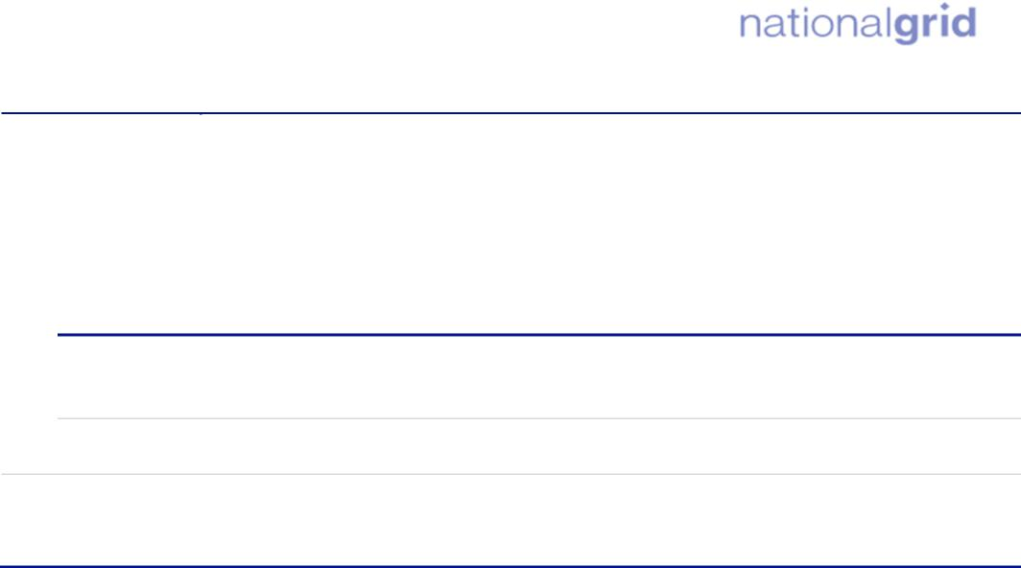
UK PROJECT
10-15 years
25-34 years
50-64 years
75-84 years
0-4 years
5-9 years
16-19 years
20-24 years
35-49 years
65-74 years
85+ years
Age
North East Derbyshire | 4.7% | 5.3% | 6.4% | 3.7% | 4.5% | 11.1% | 17.2% | 22.3% | 13.1% | 8.8% | 2.9%
Sheffield | 5.4% | 5.8% | 6.8% | 5.6% | 9.1% | 14.3% | 17.9% | 18.0% | 8.9% | 5.9% | 2.3%
England | 5.4% | 5.9% | 7.2% | 4.6% | 6.0% | 13.6% | 19.4% | 19.4% | 9.8% | 6.1% | 2.4%

Country
Sex
5.2.6 Table 5 presents the breakdown of males and females within the LSOAs, districts, and
England. It indicates that the percentage of males (all ages) and females (all ages) in Rotherham, Sheffield, Chesterfield and North East Derbyshire is similar to the England average in 2021. LSOAs Rotherham 027E, Rotherham 026A, North East Derbyshire 007C and North East Derbyshire 007B have a marginally higher proportion of male residents, whereas all the other geographies have a higher proportion of female residents; however this is not statistically significant across any of these geographies.

EDEU-WSP-ENVS-ZZZZZZ-RPT-EV-000001 PA-Publicaly Available
EXPORT CONTROLLED: Y 24

UK PROJECT

Table 5 - Percentage sex breakdown of the Project (2021) ¹⁵
LSOA
 | Sex  Female | Male
Rotherham 027E | 49.9% | 50.1%
Rotherham 034G | 52.1% | 47.9%
Rotherham 027D | 51.0% | 49.0%
Rotherham 027C | 51.7% | 48.3%
Rotherham 026A | 49.9% | 50.1%
Rotherham 031A | 51.0% | 49.0%
Rotherham 027H | 52.6% | 47.4%
Sheffield 056A | 50.3% | 49.7%
Sheffield 063A | 52.7% | 47.3%
Sheffield 063B | 50.6% | 49.4%
Sheffield 063D | 51.0% | 49.0%
Sheffield 065A | 51.5% | 48.5%
North East Derbyshire 001E | 51.9% | 48.1%
North East Derbyshire 001F | 51.9% | 48.1%
North East Derbyshire 014C | 51.6% | 48.4%
North East Derbyshire 007C | 49.6% | 50.4%

15 Nomis (2021) Local Area Profiles. Available at:
https://www.nomisweb.co.uk/reports/localarea?compare=E07000146#section_4. (Accessed July 2026).
EDEU-WSP-ENVS-ZZZZZZ-RPT-EV-000001 PA-Publicaly Available
EXPORT CONTROLLED: Y 25

Disability

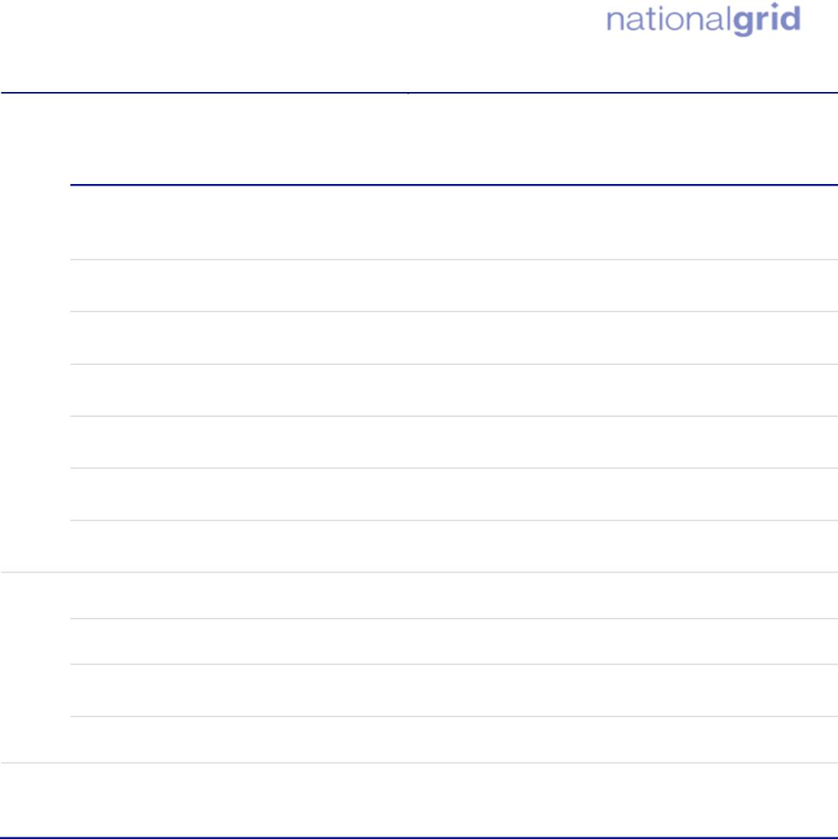
UK PROJECT
District
 | Sex  Female | Male
North East Derbyshire 007B | 50.8% | 49.2%
Chesterfield 002A | 51.9% | 48.1%
Chesterfield 002B | 51.6% | 48.4%
Chesterfield 002C | 51.2% | 48.8%
Chesterfield 002D | 51.5% | 48.5%
Chesterfield 006A | 51.2% | 48.8%
Chesterfield 006C | 51.2% | 48.8%
Rotherham | 51.0% | 49.0%
Chesterfield | 50.9% | 49.1%
North East Derbyshire | 51.2% | 48.8%
Sheffield | 50.7% | 49.3%
England | 51.0% | 49.0%

Country
Table 6 shows the proportion of the population across the LSOAs who report having a longterm health problem or disability. Overall, in Rotherham, Sheffield, Chesterfield and North East Derbyshire, there is a higher proportion of people who are disabled according to the Equality Act (and their day to day activities are limited a lot or a little) than the England average. In LSOAs Rotherham 027D, North East Derbyshire 007B, Chesterfield 002D and Chesterfield 006C, there is a much higher proportion of people who have a disability and are limited a little or a lot when compared to the districts and England averages. By contrast, LSOA Sheffield 063D, Sheffield 056A, North East Derbyshire 001E, Rotherham 031A and Rotherham 027C has a much lower proportion of people with a disability whose activities are limited a little and a lot when compared with the districts and England averages. These LSOAs subsequently also have the highest proportion of people who have no long term physical or mental health conditions.
EDEU-WSP-ENVS-ZZZZZZ-RPT-EV-000001 PA-Publicaly Available
EXPORT CONTROLLED: Y 26

UK PROJECT

Table 6 - Percentage disability breakdown of the Project (2021) ¹⁶

Disability  Disabled under the Equality Act: Day-to-day activities limited a lot | Disabled under the Equality Act: Day-to-day activities limited a little | Not disabled under the Equality Act: Has long term physical or mental health condition but day-to-day activities are not limited | Not disabled under the Equality Act: No long term physical or mental health conditions

LSOA
Rotherham 027E | 8.4% | 12.6% | 7.7% | 71.3%
Rotherham 034G | 9.2% | 11.2% | 7.1% | 72.5%
Rotherham 027D | 13.8% | 14.6% | 6.0% | 65.5%
Rotherham 027C | 7.4% | 8.8% | 7.1% | 76.6%
Rotherham 026A | 8.5% | 11.6% | 8.7% | 71.3%
Rotherham 031A | 6.6% | 8.6% | 8.1% | 76.6%
Rotherham 027H | 9.0% | 10.6% | 6.3% | 74.1%
Sheffield 056A | 8.7% | 9.8% | 8.3% | 73.2%
Sheffield  063A | 7.2% | 11.6% | 8.2% | 72.9%
Sheffield  063B | 5.8% | 10.0% | 8.5% | 75.7%
Sheffield | 4.1% | 8.7% | 9.4% | 77.8%
063D
16 Nomis (2021) Local Area Profiles. Available at:
https://www.nomisweb.co.uk/reports/localarea?compare=E07000146#section_4. (Accessed July 2026).
EDEU-WSP-ENVS-ZZZZZZ-RPT-EV-000001 PA-Publicaly Available
EXPORT CONTROLLED: Y 27

UK PROJECT

Disability  Disabled under the Equality Act: Day-to-day activities limited a lot | Disabled under the Equality Act: Day-to-day activities limited a little | Not disabled under the Equality Act: Has long term physical or mental health condition but day-to-day activities are not limited | Not disabled under the Equality Act: No long term physical or mental health conditions

Sheffield 065A | 9.4% | 13.6% | 8.5% | 68.5%
North East Derbyshire  001E | 7.2% | 8.8% | 7.8% | 76.2%
North East Derbyshire  001F | 8.8% | 10.4% | 7.1% | 73.8%
North East Derbyshire 014C | 8.2% | 11.0% | 7.0% | 73.8%
North East Derbyshire 007C | 11.1% | 11.2% | 6.6% | 71.1%
North East Derbyshire 007B | 10.7% | 17.2% | 9.4% | 62.7%
Chesterfield  002A | 11.8% | 13.2% | 5.7% | 69.3%
Chesterfield  002B | 10.7% | 12.1% | 7.3% | 69.9%
Chesterfield  002C | 11.8% | 12.7% | 9.0% | 66.5%
Chesterfield  002D | 12.1% | 14.2% | 6.8% | 66.9%
Chesterfield | 12.8% | 13.7% | 6.1% | 67.4%
006A
EDEU-WSP-ENVS-ZZZZZZ-RPT-EV-000001 PA-Publicaly Available
EXPORT CONTROLLED: Y 28

UK PROJECT

Country

District

Disability  Disabled under the Equality Act: Day-to-day activities limited a lot | Disabled under the Equality Act: Day-to-day activities limited a little | Not disabled under the Equality Act: Has long term physical or mental health condition but day-to-day activities are not limited | Not disabled under the Equality Act: No long term physical or mental health conditions

Chesterfield 006C | 12.3% | 14.5% | 8.7% | 64.5%
Rotherham | 9.0% | 10.6% | 6.3% | 74.1%
Chesterfield | 10.3% | 12.8% | 7.6% | 69.4%
North East Derbyshire | 9.3% | 12.0% | 7.7% | 71.0%
Sheffield | 8.5% | 11.2% | 7.3% | 72.9%
England | 7.3% | 10.0% | 6.8% | 75.9%

*Note: Percentages may not sum exactly due to rounding.
Marriage and Civil Partnership
Table 7 presents the Census 2021 marital and civil partnership status in each of the LSOAs, Rotherham, Sheffield, Chesterfield and North East Derbyshire, and England for all usual residents aged 16 and over. Rotherham, Chesterfield and North East Derbyshire have a lower population who are single and a larger population who are married when compared to the England averages. Other marital or civil partnership statuses are generally in line with those for England, however there are slightly more people who are divorced or have dissolved their civil partnership in Rotherham, Chesterfield and North East Derbyshire. Some of the LSOAs have a slightly lower proportion of single people when compared to the England and district averages, specifically Chesterfield 006C with only 19.8% of the population having never married and never registered a civil partnership. In turn, these LSOAs also have a higher proportion of people who are married or in a civil partnership when compared with the district and England averages. Chesterfield 002D and Chesterfield 002A are two outliers with a slightly higher proportion of single people when compared to the district and England averages.
EDEU-WSP-ENVS-ZZZZZZ-RPT-EV-000001 PA-Publicaly Available
EXPORT CONTROLLED: Y 29

UK PROJECT

Table 7: Percentage marriage / civil partnership breakdown of the Project (2021) ¹⁷
Marriage/Civil Partnership Profile

Divorced or civil
partnership
dissolved
Married or in a registered civil partnership
Widowed or surviving civil partnership partner
Separated, but still legally
married or in a civil partnership
Never married and never
registered a civil partnership
LSOA
Rotherham 027E | 34.6% | 48.9% | 0.8% | 9.4% | 6.3%
Rotherham 034G | 29.1% | 50.8% | 2.0% | 10.7% | 7.5%
Rotherham 027D | 41.1% | 40.5% | 3.0% | 8.9% | 6.5%
Rotherham 027C | 34.6% | 48.7% | 1.9% | 9.4% | 5.4%
Rotherham 026A | 24.3% | 58.2% | 1.2% | 9.2% | 7.1%
Rotherham 031A | 33.8% | 52.1% | 1.8% | 8.0% | 4.4%
Rotherham 027H | 37.5% | 43.0% | 2.5% | 7.9% | 9.1%
Sheffield 056A | 38.3% | 43.9% | 1.5% | 9.8% | 6.4%
Sheffield 063A | 33.3% | 48.2% | 2.3% | 7.4% | 8.8%
Sheffield 063B | 26.5% | 61.1% | 1.0% | 5.8% | 5.6%
Sheffield 063D | 28.1% | 60.2% | 1.6% | 6.1% | 3.9%
Sheffield 065A | 38.4% | 42.5% | 2.4% | 10.1% | 6.6%
North East Derbyshire 001E | 28.6% | 52.9% | 1.4% | 9.7% | 7.4%
North East Derbyshire 001F | 29.4% | 51.4% | 1.2% | 11.8% | 6.1%

17 Nomis (2021) Local Area Profiles. Available at:
https://www.nomisweb.co.uk/reports/localarea?compare=E07000146#section_4. (Accessed July 2026).
EDEU-WSP-ENVS-ZZZZZZ-RPT-EV-000001 PA-Publicaly Available
EXPORT CONTROLLED: Y 30

UK PROJECT

Marriage/Civil Partnership Profile

Divorced or civil
partnership
dissolved
Married or in a registered civil partnership
Widowed or surviving civil partnership partner
Separated, but still legally
married or in a civil partnership
Never married and never
registered a civil partnership
Country

District

North East Derbyshire 014C | 39.0% | 41.3% | 2.5% | 11.4% | 5.8%
North East Derbyshire 007C | 30.9% | 51.2% | 2.4% | 8.6% | 6.9%
North East Derbyshire 007B | 30.1% | 49.5% | 1.6% | 9.7% | 9.2%
Chesterfield 002A | 47.4% | 35.0% | 2.6% | 10.4% | 4.6%
Chesterfield 002B | 28.5% | 51.5% | 1.1% | 10.1% | 8.7%
Chesterfield 002C | 38.2% | 29.1% | 2.6% | 13.2% | 7.0%
Chesterfield 002D | 46.6% | 32.1% | 2.9% | 13.0% | 5.5%
Chesterfield 006A | 36.0% | 44.1% | 2.2% | 9.3% | 8.4%
Chesterfield 006C | 19.8% | 59.9% | 1.4% | 7.7% | 11.2%
Rotherham | 36.0% | 45.3% | 2.2% | 9.6% | 6.9%
Chesterfield | 35.7% | 43.5% | 2.3% | 11.2% | 7.2%
North East Derbyshire | 30.5% | 49.4% | 2.1% | 10.3% | 7.7%
Sheffield | 44.2% | 40.1% | 2.0% | 7.8% | 5.8%
England | 37.9% | 44.7% | 2.2% | 9.1% | 6.1%

EDEU-WSP-ENVS-ZZZZZZ-RPT-EV-000001 PA-Publicaly Available
EXPORT CONTROLLED: Y 31

District
Country
UK PROJECT

Sexual Orientation
5.2.7 Data for sexual orientation is only available at the local authority level, therefore
comparison between Rotherham, Sheffield, Chesterfield, North East Derbyshire and England is included here.
5.2.8 Table 8 shows that the Rotherham, Sheffield, Chesterfield and North East Derbyshire
profiles are broadly in line with the England averages. There is a marginally lower proportion of Gay or Lesbian people in Rotherham and North East Derbyshire (1.2% and 1.1%) when compared with the England (1.5%) average, as well as a slightly lower proportion of Bisexual people (Rotherham is 0.9%, North East Derbyshire is 0.8% whereas England is 1.3%). These ratios are not statistically significant, however and suggest the geographies in the Study Areas are broadly representative of the England average as a whole.
Table 8: Percentage sexual orientation breakdown of the Project (2021) ¹⁸
Sexual Orientation

Rotherham | 91.6% | 1.2% | 0.9% | 0.1% | 0.0% | 0.0% | 0.1% | 6.0%
Chesterfield | 90.6% | 1.5% | 1.2% | 0.1% | 0.1% | 0.0% | 0.1% | 6.5%
North East Derbyshire | 92.0% | 1.1% | 0.8% | 0.1% | 0.0% | 0.0% | 0.0% | 5.9%
Sheffield | 88.0% | 1.6% | 2.0% | 0.2% | 0.1% | 0.1% | 0.2% | 7.9%
England | 89.4% | 1.5% | 1.3% | 0.1% | 0.1% | 0.0% | 0.2% | 7.5%

Not answered
Pansexual
Bisexual
Asexual
All other
sexual
orientations
Straight/
Heterosexual
Gay or Lesbian
Queer
*Note: Percentages may not sum exactly due to rounding.
Gender Identity and Reassignment
5.2.9 Data for gender identity is only available at the local authority level, therefore comparison between Rotherham, Sheffield, Chesterfield, North East Derbyshire and England is included here.
5.2.10 Table 9 shows that the Rotherham, Sheffield, Chesterfield and North East Derbyshire profiles are largely in line with the England averages. A slightly higher proportion of
18 Nomis (2021) Local Area Profiles. Available at:
https://www.nomisweb.co.uk/reports/localarea?compare=E07000146#section_4. (Accessed July 2026).
EDEU-WSP-ENVS-ZZZZZZ-RPT-EV-000001 PA-Publicaly Available
EXPORT CONTROLLED: Y 32

UK PROJECT

people in Sheffield did not provide an answer (6.3%), compared with Chesterfield (5.3%), Rotherham (4.9%) and North East Derbyshire (4.9%) and the England average (6.0%). Sheffield also has a marginally higher proportion of residents who selected ‘All other gender identities’ (0.1%) compared with England, Chesterfield, Rotherham and North East Derbyshire (0.0%). However, as with the sexual orientation data presented above, this difference is not statistically significant. This suggests that the proportion of people identifying as non-binary, or as a gender different from that they were assigned at birth, is broadly in line with the England average.
Table 9: Percentage gender identity breakdown of the Project (2021) ¹⁹
Gender Identity
Not answered
Non-binary
Trans man
Trans woman
All other gender identities
Gender Identity the
same as sex registered
at birth
Gender identity different from sex registered at birth but no specific
identity given
District
Country
Rotherham | 94.6% | 0.3% | 0.1% | 0.1% | 0.0% | 0.0% | 4.9%
Chesterfield | 94.4% | 0.1% | 0.1% | 0.1% | 0.0% | 0.0% | 5.3%
North East Derbyshire | 94.9% | 0.1% | 0.0% | 0.0% | 0.0% | 0.0% | 4.9%
Sheffield | 92.9% | 0.3% | 0.1% | 0.1% | 0.1% | 0.1% | 6.3%
England | 93.5% | 0.2% | 0.1% | 0.1% | 0.1% | 0.0% | 6.0%

Pregnancy and Maternity
5.2.11 Data for pregnancy and maternity is only available at the local authority level, therefore comparison between Rotherham, Sheffield, Chesterfield, North East Derbyshire and England is included here.
5.2.12 Table 10 shows that the Crude birth rate is slightly higher in Rotherham and Sheffield, meaning there are more live births in 2025 per 1,000 mid-year population (10.1 and 9.7) compared to the England, Chesterfield and North East Derbyshire averages (9.5,
19 Nomis (2021) Local Area Profiles. Available at:
https://www.nomisweb.co.uk/reports/localarea?compare=E07000146#section_4. (Accessed July 2026).
EDEU-WSP-ENVS-ZZZZZZ-RPT-EV-000001 PA-Publicaly Available
EXPORT CONTROLLED: Y 33

UK PROJECT

8.4 and 8.0 respectively). Rotherham has a higher general fertility rate (GFR) and total fertility rate (TFR) than Chesterfield, North East Derbyshire, Sheffield and England as shown in Table 10. The higher GFR rate suggests there are more babies born per 1000 women of childbearing age, whilst the higher TFR suggests that women in Rotherham have given birth to a slightly higher number of children than the England average. Overall, the Rotherham, Sheffield, Chesterfield and North East Derbyshire profiles are broadly in line with the England averages.
Table 10: Percentage pregnancy and maternity breakdown of the Project (2025)²⁰
Pregnancy and Maternity

Rotherham | 10.1 | 53.4 | 1.59
Chesterfield | 8.4 | 47.2 | 1.38
North East Derbyshire | 8.0 | 48.3 | 1.40
Sheffield | 9.7 | 44.0 | 1.31
England | 9.5 | 48.2 | 1.39

Crude birth rate*
General fertility rate (GFR)**
Total fertility rate (TFR)***
District
Country
*Crude Birth Rate is the number of live births in a year, per 1,000 of the population.
**General Fertility Rate is the number of live births per 1,000 women aged 15-44.
***Total Fertility Rate is the average number of live children that a group of women (for example at a specific geographic level) would have throughout their childbearing lifespan.
20 Nomis (2025) Live births in England and Wales: birth rates down to local authority areas. Available at: https://www.nomisweb.co.uk/query/construct/components/simpleapicomponent.aspx?menuopt=2027&subcomp=. (Accessed August 2026).
EDEU-WSP-ENVS-ZZZZZZ-RPT-EV-000001 PA-Publicaly Available
EXPORT CONTROLLED: Y 34

UK PROJECT

Deprivation
5.2.13 The Indices of Multiple Deprivation (IMD) 2025²¹ use a combination of information relating to income, employment, education, health, skills and training, barrier to housing and services, and crime to create an overall score of deprivation. These scores are then used to rank specific geographical extents, out of a total of
33,755 areas in England. A low rank indicates higher, relative deprivation; hence the most deprived area is ranked 1. The Project lies within 23 LSOAs.
- Overall, there is a broad range of deprivation along the CPO Boundary. There are pockets of deprivation in the LSOAs around Staveley (in the Chesterfield LSOAs).
- Chesterfield 002D is ranked the lowest (2,540), and therefore most deprived, out of all the LSOAs that intersect the Project. Conversely, North East Derbyshire 006C is ranked the highest, and therefore the least deprived, at 33,535.
- Both Chesterfield 002D and Chesterfield 002A are ranked in the 10% most deprived LSOAs, with Sheffield 063B being ranked in the least 10% deprived overall.
- Across all the LSOAs in which the Project is located, five rank as within the 10% most deprived within the Health Deprivation and Disability category of deprivation.
- Across all the LSOAs in which the Project is located, three rank within the 10% least deprived in the Crime category of deprivation.
5.3 Communities in Proximity to the Project
5.3.1 Residential streets that cross through the Project, and are adjacent to the CPO Boundary, include Swallow Wood Road, Meadow Gate Avenue, Staveley Road, and Oaks Farm Lane. The residential communities along Bole Hill, Top Road, Inkersall Green Road, Erin Road, Worksop Road, A6135, B6058, Sheffield Road, Smallage Lane, Treeton Lane and Pleasley Road are also likely to be impacted due to these roads crossing through the Project and their proximity key access routes.
5.3.2 The Project is located within a semi-rural area, with significant urban
surroundings such as Chesterfield, Westfield, Rotherham and Sheffield. These areas offer access to local facilities for the surrounding settlements, and includes healthcare, community facilities, education, employment and transport connections. Journeys to the urban centres are likely to be made by walking, cycling and by public and private vehicles, via main roads such as the A618 and M1.
5.4 Public Transport, Pedestrian and Cycling Facilities
5.4.1 There are several PROW, cycle paths and transportation facilities located within the Study Area. Households with lower incomes are least likely to have access to a private
21 Ministry of Housing, Communities and Local Government. (2025). Indices of Deprivation. Available at: https://www.gov.uk/government/statistics/english-indices-of-deprivation-2025 (Accessed July 2026)
EDEU-WSP-ENVS-ZZZZZZ-RPT-EV-000001 PA-Publicaly Available
EXPORT CONTROLLED: Y 35

UK PROJECT

vehicle therefore access to public transport and active travel opportunities are important to this group²². These are identified below.
Public Transport
5.4.2 The CPO Boundary intersects roads which may be used by public transport providers. Bus routes using these roads may include: 27, 29, X5, 80, 26, 53, 77, 81, 1, 1A and 48²³.
Walkers, Cyclists and Horse-riders
5.4.3 The CPO intersects footpaths which may be used by walkers, cyclists and horse-riders (WCH). The number of footpaths which intersect the Project are listed below:
- 12 footpaths within the Rotherham County district intersect the CPO Boundary²⁴.
- five footpaths and two bridleways (BEI/77 and ECK/175) within the Sheffield County district intersect the CPO Boundary²⁵.
- 23 footpaths and two bridleways (Eckington BW 53 and Eckington BW 105) within the Derbyshire County area intersect the CPO Boundary²⁶.
5.4.4 Additionally, the Trans Pennine Trail - Arkwright to Killamarsh/County Boundary, the Cuckoo Way and the Sheffield Country Walk travel within the CPO Boundary, as does
the national cycle network (NCN) 87 and other unnamed cycle routes. These
routes are longer distance routes and may be used by people from the wider region.
5.5 Equality Receptors
5.5.1 A number of equality receptors situated within the CPO Boundary have been identified. Equality receptors identified in this section are not considered to be exhaustive and further receptors may be identified during the CPO process.
5.5.2 The equality receptors identified are community and educational facilities, including a nursery and a number of public parks. These have the potential to be used by a disproportionately high number of people belonging to protected characteristic groups (e.g. children and young people within schools and pregnant women ).
²² Department for Transport (2024) National Travel Survey 2024: Introduction and Main Findings. Available at: https://www.gov.uk/government/statistics/national-travel-survey-2024/nts-2024-introduction-and-main-findings#main-findings (Accessed August 2026).
²³ Busatlas (2022) Principal Inter-Urban Bus Routes. Available at: https://busatlas.uk/ (Accessed July 2026)
²⁴ Rotherham Metropolitan Borough Council (2026) Public rights of way, Available at: https://maps.rotherham.gov.uk/webmapping/en-gb/PublicMap/PROW#/frontPage (Accessed July 2026)
25 Sheffield city Council (2026) Public Rights of Way map. Available at:
https://sheffieldcc.maps.arcgis.com/apps/instant/sidebar/index.html?appid=afe7156b98c74210ba280fc4f229c072 (Accessed July 2026)
26 Derbyshire County Council (2026) Derbyshire mapping portal. Available at:
https://maps.derbyshire.gov.uk/connect/analyst/mobile/#/main?mapcfg=Ordnance_Survey_Maps (Accessed July 2026)
EDEU-WSP-ENVS-ZZZZZZ-RPT-EV-000001 PA-Publicaly Available
EXPORT CONTROLLED: Y 36

UK PROJECT

5.5.3 There are no religious buildings or healthcare or social care providers within the immediate vicinity of the CPO Boundary.
Residential Receptors
5.5.4 The Project intersects approximately 49 residential properties situated on Newcroft Close, Farmoor Gardens and Meadow Gate Avenue in Sothall, approximately 9 properties situated on West Park Drive in Swallownest, approximately 15 properties situated on Poolsbrook View and Staveley Road in Poolsbrook and one property situated on Chesterfield Road in Calow. The Project intersects agricultural holdings which may contain residential properties.
5.5.5 A potential travellers’ site has been identified on Dark Lane, north of Chesterfield Substation. Although not a designated travellers’ site, there have been a number of planning applications made since 2003 that describe the site as used for accommodation for travellers²⁷.
Educational Facilities
The following educational facility has been identified in the vicinity of the CPO Boundary:
- Sunnybank Daycare Nursery, Calow, adjacent to the CPO Boundary.
Community Assets and Other Facilities
The following community assets have been identified within the vicinity of the CPO Boundary:
- West Park Drive Play Park, Swallownest, within the CPO Boundary;
- Beighton Sports Ground, Beighton, adjacent to the CPO Boundary;
- Rother Valley Country Park, adjacent to the CPO Boundary (Rother Valley Way Car Park is within the CPO Boundary);
- Great Central Line Linear Park, Renishaw, within the CPO Boundary; and
- Poolsbrook Country Park, Poolsbrook, within the CPO Boundary.
27 North East Derbyshire Council (2026) Planning Portal – Property History: Land Adjacent West Side of Jubilee Cottages, Dark Lane, Calow. Available at: https://planapps-online.ne-derbyshire.gov.uk/online-applications/propertyDetails.do?activeTab=relatedCases&keyVal=LC34I9LI03900 (Accessed July 2026).
EDEU-WSP-ENVS-ZZZZZZ-RPT-EV-000001 PA-Publicaly Available
EXPORT CONTROLLED: Y 37

UK PROJECT

6. Equality Impact Screening
6.1.1 This section presents the Equality Impact Screening assessment completed for the
Project, taking into account the baseline information outlined in this document in Section 5.
6.1.2 The screening assessment is presented in Table 11 and supported by the rationale
provided in the following sections.
Table 11 - Screening Assessment
Potential Impact
Negative Impact Positive Impact
Ethnicity Potential for adverse No positive impacts likely
impacts. for this protected
characteristic.
Religion No likely disproportionate No positive impacts likely
adverse effects to this for this protected
protected characteristic. characteristic.
Age Potential for adverse No positive impacts likely
impacts. for this protected
characteristic.
Sex No likely disproportionate No positive impacts likely
adverse effects to this for this protected
protected characteristic. characteristic.
Disability No likely disproportionate No positive impacts likely
adverse effects to this for this protected
protected characteristic. characteristic.
Marriage and Civil No likely disproportionate No positive impacts likely
Partnership adverse effects to this for this protected
protected characteristic. characteristic.
Sexual Orientation No likely disproportionate No positive impacts likely
adverse effects to this for this protected
protected characteristic. characteristic.
EDEU-WSP-ENVS-ZZZZZZ-RPT-EV-000001 PA-Publicaly Available
EXPORT CONTROLLED: Y 38

UK PROJECT

Gender identity / No likely disproportionate No positive impacts likely
transgender adverse effects to this for this protected
protected characteristic. characteristic.
Deprivation Potential for adverse No positive impacts likely
impacts. for this group.
6.2 Race
6.2.1 According to data collected for the baseline (presented in Section 5.2), the ethnicity profile for the districts is broadly representative of the England average as a whole, however there is a higher proportion of people who are white across the LSOAs when compared with the England average.
6.2.2 There is an undesignated travellers site included within the CPO Boundary; this group may potentially be affected. As a result, race is considered for further assessment within the EqIA.
6.3 Religion or Belief
6.3.1 According to data collected for the baseline, the religious profile for the districts is broadly representative of the England average as a whole.
6.3.2 There are no known equality receptors likely to be specifically used by this protected characteristic group in the vicinity of the CPO Boundary. There is no clear evidence, data or rationale to consider that the Project will have a disproportionate effect on this group the time of writing, therefore it is not considered further within the EqIA.
6.4 Age
6.4.1 According to data collected for the baseline, the age profile across the LSOAs suggests a higher proportion of people who are aged 65 and over when compared with the England average. This suggests an ageing population.
6.4.2 There is also a nursery, alongside multiple parks and play areas within the vicinity of the CPO Boundary, which are likely to be used by those under the age of 15. As a result, age (both older and younger people) is considered for further assessment within the EqIA.
6.5 Sex (Including Pregnancy and Maternity)
6.5.1 Data presented in the baseline shows that there are no statistically significant differences between the proportion of men and women across the LSOAs when compared to district and England averages. Additionally, birth rates and fertility rates show that across the districts Rotherham has a slightly higher proportion of live births per 1,000 women aged 15-44 and live births in a year, per 1,000 of the population. However, overall, there are no statistically significant differences between the districts and the England averages.
EDEU-WSP-ENVS-ZZZZZZ-RPT-EV-000001 PA-Publicaly Available
EXPORT CONTROLLED: Y 39

UK PROJECT

6.5.2 There are no receptors in the vicinity of the CPO Boundary which are more likely to be used by men or women, however women are more likely to be escorts for children travelling to school. As the Project has no direct interaction with roads used to transport children to and from the identified nursery, it is unlikely that the Project will have a disproportionate effect on women at the time of writing, therefore it is not considered further within the EqIA.
6.6 Disability
6.6.1 According to data collected for the baseline, the disability profile across the LSOAs and districts suggests a slightly higher proportion of people who are disabled when compared with the England average.
6.6.2 There are no known service providers or receptors likely to be specifically used by this protected characteristic group in the vicinity of the CPO Boundary. There is no clear evidence, data or rationale to consider that the Project will have a disproportionate effect on this group the time of writing, therefore it is not considered further within the EqIA.
6.7 Marriage and Civil Partnership
6.7.1 According to data collected for the baseline, the marriage and civil partnership profile for the districts is broadly representative of the England average as a whole.
6.7.2 There are no known service providers or receptors likely to be specifically used by this protected characteristic group in the vicinity of the CPO Boundary. There is no clear evidence, data or rationale to consider that the Project will have a disproportionate effect on this group the time of writing, therefore it is not considered further within the EqIA.
6.8 Sexual Orientation
6.8.1 According to data collected for the baseline, the sexual orientation profile for the districts is broadly representative of the England average as a whole.
6.8.2 There are no known service providers or receptors likely to be specifically used by this protected characteristic group in the vicinity of the CPO Boundary. There is no clear evidence, data or rationale to consider that the Project will have a disproportionate effect on these groups at the time of writing, therefore it is not considered further within the EqIA.
6.9 Gender Identity / Reassignment
6.9.1 According to data collected for the baseline, the gender identity/transgender profile for the districts is broadly representative of the England average as a whole.
6.9.2 There are no known service providers or receptors likely to be specifically used by this protected characteristic group in the vicinity of the CPO Boundary. There is no clear evidence, data or rationale to consider that the Project will have a disproportionate effect on this group the time of writing, therefore it is not considered further within the EqIA.
EDEU-WSP-ENVS-ZZZZZZ-RPT-EV-000001 PA-Publicaly Available
EXPORT CONTROLLED: Y 40

UK PROJECT

6.10 Deprivation
6.10.1 According to data collected for the baseline, the deprivation profile across the LSOAs is generally mixed. There are some pockets of deprivation, particularly around Staveley.
6.10.2 Poolsbrook Country Park is located near Staveley, and may be used by the local population to take advantage of recreational opportunities and to experience time in nature. It is likely to be an important resource for the community. As such, deprivation will be considered further within the EqIA.
6.11 Summary
6.11.1 In summary, the protected characteristics which will be considered further in the assessment are age and ethnicity, as well as deprivation.
EDEU-WSP-ENVS-ZZZZZZ-RPT-EV-000001 PA-Publicaly Available
EXPORT CONTROLLED: Y 41

7. Equality Impact Assessment
UK PROJECT |  | 

7.1.1 Table 11 below presents the Equality Impact Assessment. This will be updated as further consultation takes place throughout the CPO process. It should be noted that no relocation or resettlement will be required as part of the CPO.
Table 12 – Equality Impact Assessment
Protected Potential Effect Additional Mitigation
Characteristic

Age (younger people) | Effect of CPO on access to parks and open spaces.  Parks within the CPO include West Drive Play Park and Beighton Sports Ground, which are likely to be used by younger members of the local population. If access to these facilities is disrupted, younger people may lose access to outdoor space, which is important for physical and mental wellbeing. There may also be PROW within the CPO boundary that are used by young people for recreation.  This is likely to be a temporary effect and will affect a small amount of the population. This is likely to be a low negative impact, which is short term and reversible. | Ensure that where possible, access is maintained to all PROWs and publicly accessible open spaces.  Should the PROW be disrupted, any temporary PROW diversions should be clearly signposted, and follow routes which are no worse in terms of accessibility than the current routes.  Where access will be temporarily restricted (e.g. for maintenance), ensure that residents in the local area are made aware of the restricted access, and the duration of it. This should be done with communication in a variety of formats, for example posts on social media, and physical notices at key arrival points.  Ensure that where access will be permanently limited, the provision of alternatives (such as permanent PROW diversion routes) within the local community is explored.

EDEU-WSP-ENVS-CHTE4_-PLN-EV-000001 PA-Publicaly Available
EXPORT CONTROLLED: Y 42

Effect of CPO on access to education facilities, and disturbance as a result of works happening at the site.  Although not within the CPO Boundary, there is one nursery which is adjacent. There may be disruptions to access during maintenance activities.  This is likely to be a temporary effect and will affect a small amount of the population. This is likely to be a low negative impact, which is short term and reversible. | Where access will be temporarily restricted, residents in the local area and users of the nursery will be made aware of the restricted access, and the duration of the disruption. This should be done with communication in a variety of formats, including posts on social media, and notices at the nursery.  Prior to the start of any works in proximity to the nursery, information on the timing of works and how nuisance from noise and air quality will be avoided will be provided, along with a site contractor number to report any complaints.

Age (older people) | Effect of CPO on access to parks and open spaces.  There are parks and networks of PROWs in the local area such as Rother Valley Country Park, Poolsbrook Country Park and the Trans Pennine Trail which could be used by older members of the local population. If access to these facilities is disrupted, older people may lose access to easily accessible outdoor space, which is important for physical and mental wellbeing.  This is likely to be a temporary effect and will affect a small amount of the population. This is likely to be a low negative impact, which is short term and reversible. | Ensure that where possible, access is maintained to all PROWs and publicly accessible open spaces.  Should the PROW be disrupted, any temporary PROW diversions should be clearly signposted, and follow routes which are no worse in terms of accessibility than the current routes.  Where access will be temporarily restricted, ensure that residents in the local area are made aware of the restricted access, and the duration of the disruption. This should be done with communication in a variety of formats, including posts on social media and physical notices at key arrival points.  Ensure that where access will be permanently limited, the provision of alternatives (such as permanent PROW diversion routes) within the local community is explored.

UK PROJECT

Communication of CPO  Those who are aged 65 and over may require additional assistance when discussing legal | Early consultation with those whose residences may be affected and what it would mean in terms of impacts, ensuring that information is provided in different formats (e.g. large print) or languages as
EDEU-WSP-ENVS-CHTE4_-PLN-EV-000001 PA-Publicaly Available
EXPORT CONTROLLED: Y 43

UK PROJECT

matters relating to the CPO, where it intersects with their land or where there may be changes in access.  This is likely to be a temporary effect and will affect a small amount of the population. This is likely to be a low negative impact, which is short term. | required. Any communication should use language that is easy to understand.  Signposting to services to support with any legal matters, such as RICS CPO Consumer Guide²⁸ and Shelter.  Compensation to be agreed as part of the CPO process, as required.  Prior to the start of any works in proximity to residents, information on the timing of works and how nuisance from noise and air quality will be avoided will be provided to those in the local area.  Where access will be temporarily restricted, ensure that residents are made aware of the restricted access, and the duration of the disruption in advance of the works. Access to residential properties should be maintained at all times.

Race Disruption to access at potential travellers site.
There is a potential travellers’ site located on Dark Lane, north of Chesterfield Substation. Residents here may experience disruption to access as a result of the works required at nearby pylons, however there will be no requirement for relocation.
This is likely to be a temporary effect and will affect a small amount of the population. This is likely to be a low negative impact, which is short term and reversible.
Early consultation with those who live on the site to discuss the CPO and what it would mean in terms of impacts, ensuring that information is provided in different formats or languages as required. Any communication should use language that is easy to understand.
Signposting to services to support with any legal matters, such as RICS CPO Consumer Guide²⁸ and Shelter.
Compensation to be agreed as part of the CPO process, as required.
Where access will be temporarily restricted, ensure that residents are made aware of the restricted access, and the duration of it in advance of the works. Access to residential properties should be maintained at all times.
²⁸ Available at: https://www.rics.org/content/dam/ricsglobal/documents/consumer-guides/cpo-consumer-guide.pdf
EDEU-WSP-ENVS-CHTE4_-PLN-EV-000001 PA-Publicaly Available
EXPORT CONTROLLED: Y 44

UK PROJECT

Deprivation Effect of CPO on access to parks and open spaces.
There are parks and networks of PROWs in the local area such as Rother Valley Country Park, Poolsbrook Country Park and the Trans Pennine Trail which could be used by more deprived members of the local population. If access to these facilities is disrupted, those in deprived communities may lose access to easily accessible and low-cost outdoor space, which is important for physical and mental wellbeing.
This is likely to be a temporary effect and will affect a small amount of the population. This is likely to be a low negative impact, which is short term and reversible.
Ensure that where possible, access is maintained to all PROWs and publicly accessible open spaces.
Should the PROW be disrupted, any temporary PROW diversions should be clearly signposted, and follow routes which are no worse in terms of accessibility than the current routes.
Where access will be temporarily restricted, ensure that residents in the local area are made aware of the restricted access, and the duration of it. This should be done with communication in a variety of formats, including posts on social media, and physical notices at key arrival points.
Ensure that where access will be permanently limited, the provision of alternatives (such as permanent PROW diversion routes) within the local community is explored.
EDEU-WSP-ENVS-CHTE4_-PLN-EV-000001 PA-Publicaly Available
EXPORT CONTROLLED: Y 45

UK PROJECT

8. Conclusions
8.1.1 In conclusion, two protected characteristic groups (age and race) are likely to experience disproportionate effects as a result of the CPO. This could manifest in changes to access to open spaces, access to PROWs, access to education, and changes in access to residential properties. Additionally, those in deprived areas may experience changes in access to open spaces and PROWs. These impacts are expected to be low, short term and reversible. These disproportionate effects could be mitigated through measures such as clear and early communication in a variety of formats and maintaining access wherever possible.
8.1.2 This EqIA will be developed as the CPO process continues. In the event that additional receptors or potential impacts relating to protected characteristics are identified, they will be included in any assessment updates.
EDEU-WSP-ENVS-CHTE4_-PLN-EV-000001 PA-Publicaly Available
EXPORT CONTROLLED: Y 46

UK PROJECT

EDEU-WSP-ENVS-CHTE4_-PLN-EV-000001 PA-Publicaly Available
EXPORT CONTROLLED: Y 47

UK PROJECT
National Grid plc
National Grid House,
48
Warwick Technology Park,
Gallows Hill, Warwick.
CV³⁴ ⁶DA United Kingdom

