National Grid - Information about our suppliers

Information about our suppliers

Top 10 Tier 1 Countries based on spend (2020 data)
We work with around 6,000 suppliers across our global organisation and the following table details the top 10 countries where our Tier 1 suppliers are based.

Country | Percentage of Spend
United States | 64.41%
United Kingdom | 32.18%
Italy | 1.10%
India | 0.70%
Germany | 0.51%
Canada | 0.47%
Luxembourg | 0.12%
Norway | 0.10%
Belgium | 0.07%
Netherlands | 0.05%

Top 25 suppliers accounting for 39% of our global supplier spend (2020 data)
We spend over £5.5bn with our global suppliers annually and 39% of this spend is with the following 25 organisations.

Supplier Name | Top Commodity
A G I CONSTRUCTION | GAS MAINS PIPE LAYING (INCL. EXCAVATION & REINSTATEMENT)
ABB | TRANSFOMERS - PRIMARY (10MVA TO 100MVA)
ADECCO GROUP | RECRUITMENT SERVICES (EXCL. IT & FINANCE)
ASPLUNDH TREE EXPERT | GAS MAINS PIPE LAYING (INCL. EXCAVATION & REINSTATEMENT)
BABCOCK INTERNATIONAL GROUP | OVERHEAD LINE SERVICES
BALFOUR BEATTY | OVERHEAD LINE SERVICES
BANCKER CONSTRUCTION | GAS MAINS PIPE LAYING (INCL. EXCAVATION & REINSTATEMENT)
BLUE CROSS & BLUE SHIELD OF MASSACHUSETTS FOUNDATION FOR EXPANDING HEALTHCARE ACCESS | PERSONNEL/HUMAN RESOURCES SERVICES
BOND Civil & Utility Construction | PIPELINE CONSTRUCTION
DXC TECHNOLOGY | HARDWARE SERVICES
ELEMENT FLEET MANAGEMENT | VEHICLE LEASING
FEENEY BROTHERS EXCAVATION | GAS MAINS PIPE LAYING (INCL. EXCAVATION & REINSTATEMENT)
GENERAL ELECTRIC | SUBSTATION TURNKEY - TRANSMISSION
J MURPHY & SONS | UNDERGROUND CABLE SERVICES
MASTEC | OVERHEAD LINE CONSTRUCTION - TOWER (100KV TO 199KV)
MORGAN SINDALL GROUP | UNDERGROUND CABLE SERVICES
PRICEWATERHOUSECOOPERS | IT CONSULTANCY (EXCL. E-COMMERCE)
PRYSMIAN | SUBSEA CABLE SERVICES
QUANTA SERVICES | GAS MAINS PIPE LAYING (INCL. EXCAVATION & REINSTATEMENT)
ROBERT J DEVEREAUX | GAS MAINS PIPE LAYING (INCL. EXCAVATION & REINSTATEMENT)
SIEMENS ENERGY | GENERATORS - POWER STATION
SOUTHWEST GAS HOLDINGS | GAS MAINS PIPE LAYING (INCL. EXCAVATION & REINSTATEMENT)
VERIZON COMMUNICATIONS | TELECOMMUNICATION NETWORK SERVICES
WESCO INTERNATIONAL | OVERHEAD LINE ACCESSORIES
WIPRO | FACILITIES MANAGEMENT SERVICES - IT

Modern Slavery Risk Assessment (2017 data)

In 2017 we completed a desktop risk assessment of our top 250 suppliers (global top 250 suppliers to the National Grid plc group based on spend) using recommended risk criteria which assessed: country of origin of the goods/service, brand association, supply chain complexity, levels of sub-contracting and category of spend.

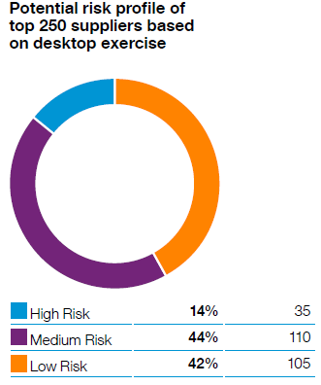 | For our top 250 suppliers, 14% were identified as potentially high risk and these related to the following categories:  - Construction/Civil works  - Substations  - Facilities - catering/cleaning/security  - Maintenance, repair and operations/PPE (personal protective equipment) and tools  - Travel Management  - Office supplies

