Information about our Suppliers

Modern Slavery Risk Assessment (2017 data)

In 2017 we completed a desktop risk assessment of our top 250 suppliers (global top 250 suppliers to the National Grid plc group based on spend) using recommended risk criteria which assessed: country of origin of the goods/service, brand association, supply chain complexity, levels of sub-contracting and category of spend.

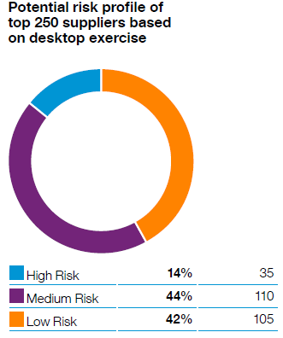 | For our top 250 suppliers, 14% were identified as potentially high risk and these related to the following categories:  - Construction/Civil works  - Substations  - Facilities - catering/cleaning/security  - Maintenance, repair and operations/PPE (personal protective equipment) and tools  - Travel Management  - Office supplies

Top 10 tier 1 countries of origin based on spend (2019 data)

[INV]Supplier (Country) | Sum of sum(Invoice Spend)
United States | 65.20%
United Kingdom | 33.92%
Canada | 0.36%
Germany | 0.11%
India | 0.08%
Norway | 0.06%
Belgium | 0.05%
South Korea | 0.05%
China | 0.04%
Ireland | 0.03%

Top 25 suppliers accounting for 42% of our global supplier spend
(2019 data)

SUPPLIER NAME | CATEGORY
ABB | SUBSTATION TURNKEY - TRANSMISSION
ACCENTURE | IT CONSULTANCY
AGI CONSTRUCTION | GAS MAINS PIPE LAYING
ASPLUNDH TREE EXPERT | GAS MAINS PIPE LAYING
BABCOCK INTERNATIONAL GROUP | OVERHEAD LINE SERVICES
BALFOUR BEATTY | OVERHEAD LINE SERVICES
BANCKER CONSTRUCTION | GAS MAINS PIPE LAYING
BLUE CROSS AND BLUE SHIELD OF MASSACHUSETTS FOUNDATION FOR EXPANDING HEALTHCARE ACCESS | PERSONNEL/HUMAN RESOURCES SERVICES
BOND CIVIL & UTILITY CONSTRUCTION | PIPELINE CONSTRUCTION
COSTAIN GROUP | COMPRESSOR MAINTENANCE
ELEMENT FLEET MANAGEMENT | FLEET RENTAL EQUIPMENT
FEENEY BROTHERS EXCAVATION | GAS MAINS PIPE LAYING
GENERAL ELECTRIC | SUBSTATION TURNKEY - TRANSMISSION
J MURPHY & SONS LTD | OVERHEAD LINE SERVICES
NEW YORK PAVING | ROAD CONSTRUCTION & SURFACING SERVICES (PAVING)
PRICE WATERHOUSE COOPERS | IT CONSULTANCY
PRYSMIAN GROUP | SUBSEA CABLE SERVICES/CABLES & ACCESSORIES
QUANTA SERVICES | GAS MAINS PIPE LAYING
ROBERT J DEVEREAUX | GAS MAINS PIPE LAYING
SIEMENS | GENERATORS - POWER STATION
SOUTHWEST GAS HOLDINGS | GAS MAINS PIPE LAYING
The ADECCO GROUP | RECRUITMENT SERVICES
VERIZON COMMUNICATIONS | TELECOMMUNICATION NETWORK SERVICES
VODAFONE GROUP | TELECOMMUNICATION NETWORK SERVICES
WIPRO | SOFTWARE DEVELOPMENT SERVICES

